DEB包

apt-get

dpkg

apt-mirror

阿里镜像源

DEB本地源

RPM包

YUM软件包管理

YUM配置

rpm包缓存到本地

centos7下使用yum安装pip

RPM本地源-文件服务

下载rpm软件包

目标主机配置本地源

RPM本地源-HTTP

本地http源服务器

目的主机测试

RPM命令

# DEB包

## apt-get

apt-get update

apt-get install vim

# 只下载不安装 /var目录

apt-get install -d vim

# 强制覆盖安装

apt-get -o Dpkg::Options::="--force-overwrite" install <package-name>

apt-get install --fix-broken

dpkg -i <deb file>

apt-get update

apt-get install -f

dpkg -i <deb file>

--allow-unauthenticated

##

WARNING:The following packages cannot be authenticated!

sudo apt-key update

sudo apt-get update

sudo apt-get update --fix-missing

sudo apt-get autoremove && sudo apt-get clean && sudo apt-get install -f

<http://www.ubuntukylin.com/ukd/home/deb2.php>

<http://www.linuxdiyf.com/viewarticle.php?id=164664>

## dpkg

dpkg -l | grep mysql | awk '{print $2}' | xargs apt-get purge -y

sudo dpkg -i --force-overwrite AAA

# 查看包的文件列表

dpkg -L apache2

//查询deb包的详细信息，没有指定包则显示全部已安装包

dpkg –l

dpkg -l |grep vim

//查看已经安装的指定软件包的详细信息

dpkg -s vim

//列出一个包安装的所有文件清单

dpkg -L vim

//查看系统中的某个文件属于那个软件包

dpkg -S vimrc

dpkg -S /lib/systemd/system/ceph-osd.target

//所有deb文件的安装

dpkg -i

//所有deb文件的卸载

dpkg -r

//彻底的卸载，包括软件的配置文件

dpkg -P

//查询deb包文件中所包含的文件

dpkg -c

//查看系统中安装包的的详细清单，同时执行 -c

dpkg -L

dpkg --purge --force-depends "gcc-multilib"

dpkg: warning: files list file for package 'X' missing; assuming package has no files currently installed

for package in $(apt-get upgrade 2>&1 |\
                 grep "warning: files list file for package '" |\
                 grep -Po "[^'\n ]+'" | grep -Po "[^']+"); do
    apt-get install --reinstall "$package";
done

for package in $(apt-get upgrade 2>&1 | grep "warning: files list file for package '" | grep -Po "[^'\n ]+'" | grep -Po "[^']+"); do apt-get install --reinstall "$package"; done

## apt-mirror

<http://forum.ubuntu.org.cn/viewtopic.php?t=53155>

## 阿里镜像源

怎么使用看 “帮助”

<https://opsx.alibaba.com/mirror>

## DEB本地源

<https://mirror.tuna.tsinghua.edu.cn/help/ubuntu/>

# sudo apt-get install nautilus-open-terminal dpkg-dev

2)创建临时目录

mkdir /tmp/debs/amd64

将deb安装包下载到该目录

生成软件包依赖信息

dpkg-scanpackages amd64 | gzip -9c >amd64/Packages.gz

3)3. 安装配置apache2服务器

apt-get install -y --force-yes openssh-server build-essential git \

python-dev python-setuptools python-pip libxml2-dev \

libxslt1.1 libxslt1-dev libgnutls-dev libnl-3-dev \

python-virtualenv libnspr-4-dev libnspr4 pkg-config \

apache2 unzip

[[ -e /usr/include/libxml ]] && rm -rf /usr/include/libxml

ln -s /usr/include/libxml2/libxml /usr/include/libxml

[[ -e /usr/include/netlink ]] && rm -rf /usr/include/netlink

ln -s /usr/include/libnl3/netlink /usr/include/netlink

将临时目录拷贝到 /var/www/html/下

2. 待安装主机

将源地址添加到/etc/apt/source.list.d/ceph.list文件中

deb http://localhost/debs/ amd64/

**# 注意目录，不要使用/root/ 目录，权限755**

deb file:///opt/deb/12.0.2/ amd64/

dpkg-scanpackages ceph /dev/null | gzip > ceph/Packages.gz

<https://help.ubuntu.com/community/Grub2/Setup>

# RPM包

## YUM软件包管理

只下载不安装

(RHEL6)

yum install yum-plugin-downloadonly

yum install --downloadonly --downloaddir=<directory> <package>

### YUM配置

cat /etc/yum.conf

[main]

cachedir=/var/cache/yum/$basearch/$releasever

**keepcache=0**

debuglevel=2

logfile=/var/log/yum.log

exactarch=1

obsoletes=1

gpgcheck=1

plugins=1

installonly_limit=5

bugtracker_url=http://bugs.centos.org/set_project.php?project_id=23&ref=http://bugs.centos.org/bug_report_page.php?category=yum

distroverpkg=centos-release

# This is the default, if you make this bigger yum won't see if the metadata

# is newer on the remote and so you'll "gain" the bandwidth of not having to

# download the new metadata and "pay" for it by yum not having correct

# information.

# It is esp. important, to have correct metadata, for distributions like

# Fedora which don't keep old packages around. If you don't like this checking

# interupting your command line usage, it's much better to have something

# manually check the metadata once an hour (yum-updatesd will do this).

# metadata_expire=90m

# PUT YOUR REPOS HERE OR IN separate files named file.repo

# in /etc/yum.repos.d

### rpm包缓存到本地

#修改yum设置，让rpm包缓存到本地

vi /etc/yum.conf

#修改keepcache为1

keepcache=1

#清空yum缓存

yum clean all

#安装你要离线安装的rpm包

yum install xxx.rpm -y

#rpm包缓存到了/var/cache/yum下面

cd /var/cache/yum

find ./ -name *.rpm

#找到rpm包，并拷走就可以离线安装了

### centos7下使用yum安装pip

首先安装epel扩展源：

yum -y install epel-release

更新完成之后，就可安装pip：

yum -y install python-pip

安装完成之后清除cache：

yum clean all

这是在root用户时使用的命令，当前用户如果不具有root权限，加上sudo。

如果pip install 出现问题可以试试命令

pip install setuptools==33.1.1

### RPM本地源-文件服务

**下载rpm软件包**

（以下已ceph为例）

# cat /etc/yum.repos.d/ceph.repo

[ceph-noarch]

name=Ceph noarch packages

baseurl=https://download.ceph.com/rpm-luminous/el7/noarch

enabled=1

gpgcheck=1

type=rpm-md

gpgkey=https://download.ceph.com/keys/release.asc

[Ceph]

name=Ceph packages for $basearch

baseurl=http://download.ceph.com/rpm-luminous/el7/$basearch

enabled=1

gpgcheck=1

type=rpm-md

gpgkey=https://download.ceph.com/keys/release.asc

[Ceph-noarch]

name=Ceph noarch packages

baseurl=http://download.ceph.com/rpm-luminous/el7/noarch

enabled=1

gpgcheck=1

type=rpm-md

gpgkey=https://download.ceph.com/keys/release.asc

[ceph-source]

name=Ceph source packages

baseurl=http://download.ceph.com/rpm-luminous/el7/SRPMS

enabled=1

gpgcheck=1

type=rpm-md

gpgkey=https://download.ceph.com/keys/release.asc

yum clean all

# 下载RPM包及依赖（只下载不安装）

yum install ceph ceph-deploy ceph-common python-rbd radosgw ceph-test --downloadonly --downloaddir=./local

### 目标主机配置本地源

拷贝rpm包到目标主机，制作本地源

scp local/*.rpm root@DEST_HOST:/local/

# 重新生成metadata

createrepo local/

# 更新本地源

createrepo --update local/

目标主机配置本地源

# cat /etc/yum.repos.d/ceph.repo

[ceph]

name=Ceph packages for $basearch

baseurl=file:///root/local

enabled=1

gpgcheck=0

type=rpm-md

#gpgkey=https://download.ceph.com/keys/release.asc

目标主机配置本地源

# cat /etc/yum.repos.d/ceph.repo

[ceph]

name=Ceph packages for $basearch

baseurl=file:///home/repo/ceph

enabled=1

gpgcheck=0

type=rpm-md

#gpgkey=<https://download.ceph.com/keys/release.asc>

[Ceph-depend]

name=Ceph noarch packages

baseurl=file:///home/repo/ceph-depend

enabled=1

gpgcheck=0

type=rpm-md

#gpgkey=https://download.ceph.com/keys/release.asc

[ceph-source]

name=Ceph source packages

baseurl=http://download.ceph.com/rpm-luminous/el7/SRPMS

enabled=0

gpgcheck=1

type=rpm-md

#gpgkey=https://download.ceph.com/keys/release.asc

### RPM本地源-HTTP

**本地http源服务器**

centos7.4 192.168.1.10/24

yum install httpd createrepo -y

#vim /etc/httpd/conf.d/welcome.conf

Options +Indexes

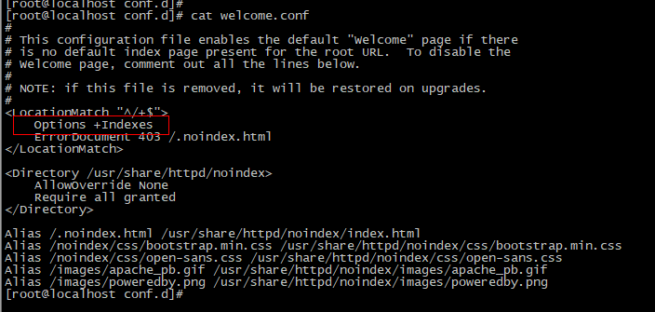

systemctl restart httpd

修改SELinux的安全策略

# 临时生效

setenforce 0

# 重启生效

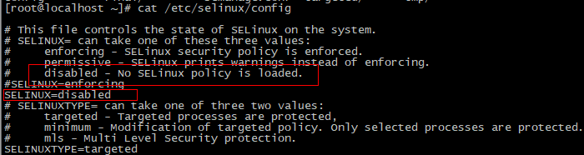

拷贝rpm包到/var/www/html目录

cd /var/www/html/

mkdir repo

cp *.rep repo/

createrepo repo

### 目的主机测试

# cat /etc/yum.repos.d/ceph.repo

[ceph-noarch]

name=Ceph noarch packages

#baseurl=https://download.ceph.com/rpm-luminous/el7/noarch

# baseurl=file:///home/repo/ceph-noarch

baseurl=http://192.168.150.11/repo/ceph-noarch

enabled=1

gpgcheck=0

type=rpm-md

#gpgkey=https://download.ceph.com/keys/release.asc

[ceph]

name=Ceph packages for $basearch

# baseurl=file:///home/repo/ceph

baseurl=http://192.168.150.11/repo/ceph

enabled=1

gpgcheck=0

type=rpm-md

[Ceph-depend]

name=Ceph depend packages

baseurl=http://192.168.150.11/repo/ceph-depend

# baseurl=file:///home/repo/ceph-depend

enabled=1

gpgcheck=0

type=rpm-md

#gpgkey=<https://download.ceph.com/keys/release.asc>

yum install ceph

## RPM命令

有时候，拿到一个RPM，并不想安装它，而想了解包里的内容，怎么办呢？

如果只相知道包里的文件列表执行：

rpm -qpl packetname

# rpm 查看文件属于哪个安装包

rpm -qf /usr/bin/lsblk

如果想要导出包里的内容，而不是安装，那么执行：

rpm2cpio pkgname | cpio -ivd

<http://download.ceph.com/rpm-luminous/el7/x86_64/>

wget -c -r -np -k -L -p http://download.ceph.com/rpm-hammer/

wget -c -r -np -k -L -p http://download.ceph.com/rpm-jewel/

wget -c -r -np -k -L -p <http://download.ceph.com/rpm-kraken/>